REMOTE JAMMING DEVICE

ABSTRACT

The project develops a remote jamming device which can jam the TV remote rays. It develops IR rays of 38 KHz usually emitted by a standard TV remote. The rays developed are powerful enough to overshadow the IR receiver in TV.
This system is built by using a 555 Timer in the astable mode which is made to produce the higher power pulses in the range of 38 KHZ emitted by an IR diode. These rays while aimed at TV receiver disables the IR sensor built in the TV. Thus, while any number is pressed on the TV remote, the IR rays sent will not have any effect on TV.
Further the project can be enhanced by using powerful IR diodes such that it can be operated from a long distance.

BLOCK DIAGRAM
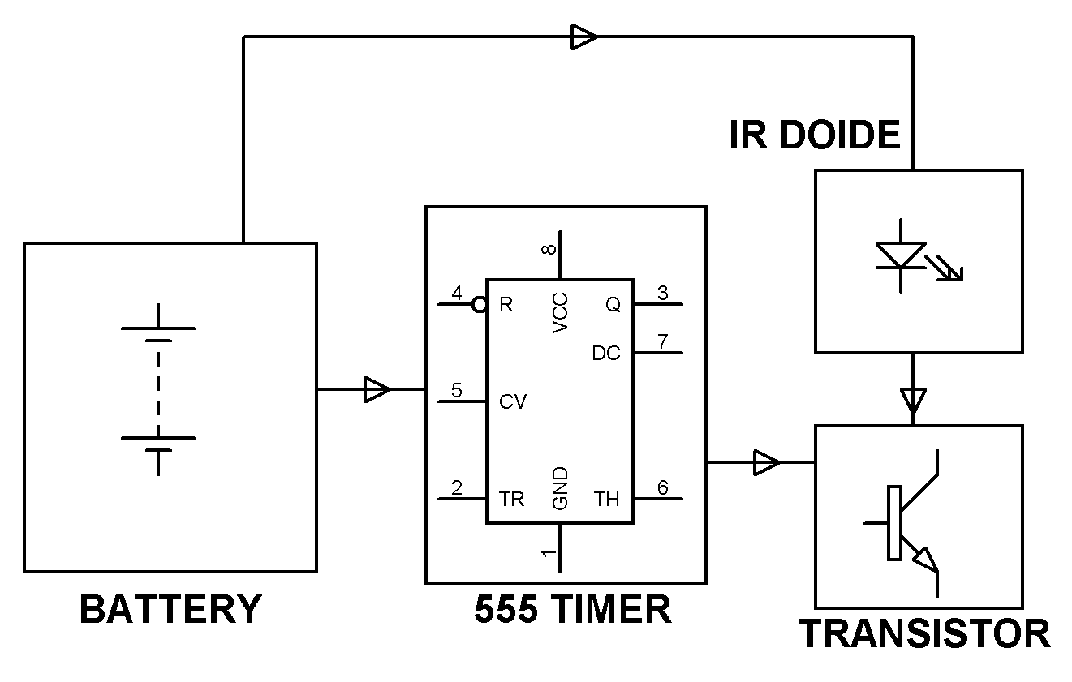
HARDWARE REQUIREMENTS:
IR LED, Timer IC, Transistors, Preset, Switch, Diodes, Capacitors, Resistors.

